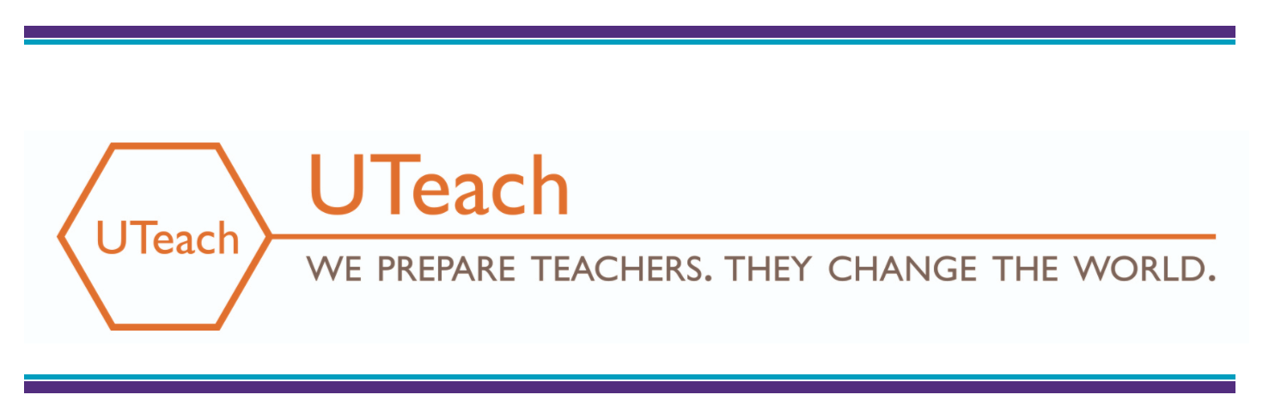
Blended Learning Observation Checklist

Teacher:
School:
Date:
Class Period:
Details:
Observer:

Blended Learning Component | Implementation | Observed | Not Observed | Notes
Relationships-﻿Students develop positive, collaborative relationships with teachers, other adults/mentors and peers which are focused on high expectations for academic and personal growth. | *Supportive teacher-student relationships have been established. Students give and receive feedback throughout the learning activities.
 | *Students are provided opportunities for peer collaboration on learning activities (i.e. station activity, think-pair-share, breakout group) that support students’ learning objectives.
 | *Students feel a sense of purpose and are part of the learning community and actively contribute to the learning community.
Rigor-﻿Students engage in the work of the lesson, think critically and do heavy lifting on content that is grade-level, college-ready or student appropriate, and continually practice and receive  feedback until mastery is demonstrated. | *A variety of instructional materials are used by students (i.e. instructional videos, discussions, questions, problems, exercises, assessments) and are appropriately demanding for the grade level and subject area.
 | *Students take part in interactive lessons that focus on relevant content and make connections to other disciplines and real-world situations.
 | *Students take academic ownership for doing the thinking and are held accountable for actively participating in the learning process.
Personalized Instruction-﻿Students are offered a variety of learning opportunities to master standards according to differentiated learning objectives dependent on students’ level of mastery, and frequently  receive individual feedback about their progress. | * ﻿Students access content through varied learning experiences which vary according to each student's need.
*Differentiated
learning objectives are used to facilitate progress for different groups of students based on students' levels of content
mastery.
 | *Individual feedback from the teacher is provided to students based on multiple means of progress monitoring. Feedback is timely and students are encouraged to reflect on progress.
 | *Technology is leveraged to enhance individual learning experiences by engaging students and holding them accountable for learning.
﻿Assessment & Data Driven Instruction-  Teachers utilize a systematic approach to assessment and data informed teaching to design and deliver instruction based on students’ specific learning needs,  monitor student learning and provide feedback to students. | *Pre and post assessments are used to guide data driven instruction.
 | * Checklists, google forms, or other tracking tools are used for monitoring progress.
*﻿When students work in groups, data is used
to form homogeneous or heterogeneous groups depending on the learning objectives.
 | *Students are assessed upon activity completion and immediate feedback is provided.
Student Agency-﻿ Students experience a level of control, autonomy and power in the educational setting. | *Process ownership is demonstrated as students have control over the path and pace of learning.
﻿*Students are encouraged to
self-advocate for their own needs, interests, and aspirations when prompted by the teacher.

﻿This checklist was informed by the following sources with support from ​McRel International​; ​Raising Blended Learners​’ Demonstration Site Implementation; ​“The Influence of Teaching Beyond Standardized Test Scores: Engagement, Mindsets, and Agency”​ Ronald F. Ferguson with Sarah F. Phillips, Jacob F. S. Rowley, and Jocelyn W. Friedlander, Harvard University, October, 2015; ​TNTP Blended Core Teaching Rubric​; ​The Dallas ISD PL Coaching and Development Rubric​.

